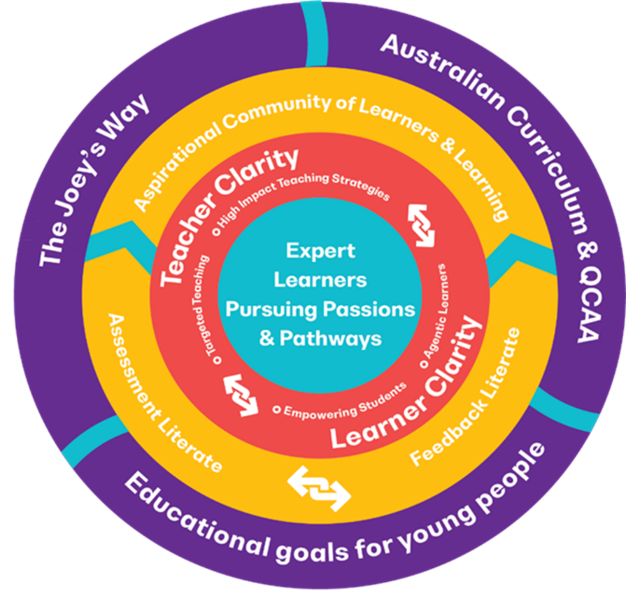Learner Clarity

Parent – Student – Teacher Clarity

As an aspirational learning community, St Joseph’s College

embraces a culture of learning to empower young people to pursue

their passions and meet the demands of their future pathways

(St Joseph’s College, Teaching & Learning Framework).

**Who should I go to when I have questions or concerns**

**about my child in the learning space?**

|  |  |
| --- | --- |
| **Classroom or Academic Questions:**   1. Your child’s classroom teacher is the first point of contact. Encourage your child to discuss any issues they are having with their teacher. 2. If a conversation with the classroom teacher has taken place, and there are still concerns or issues, parents are encouraged to contact their child’s teacher. Classroom teachers are best placed to answer any questions about classwork, assessment expectations, or course requirements. 3. If further clarification is required about your child’s learning, then please contact the relevant Curriculum Leader who will work cooperatively to resolve any issues or concerns. 4. If you have questions about courses of study and subject selection, please contact the Middle or Senior Years Program Leader or the Assistant Principal of Curriculum. 5. Queensland Certificate of Education (QCE) and subject tracking concerns of issues should be directed towards the Program Leader for Senior Years or the Assistant Principal of Curriculum. 6. If there are concerns or issues around extensions or AARA application, please contact the relevant Program Leader or Assistant Principal of Curriculum. | **Pathway or Career Questions:**   1. If you have questions about the School Based Apprenticeships or Traineeships, or wish to inquire about this opportunity, please contact the Careers Team. 2. Additional information or inquiries about courses of study outside of the College (TAFE/Aurora), should be directed towards the Careers Team. 3. Any questions regarding University courses, Headstart programs or QTAC applications should be directed to the Career Development Practitioner. 4. Further information or support around Career planning can be sought from the Career Development Practitioner. 5. If your child has recently started a Certificate course or School Based Apprenticeship or Traineeship and wishes to discuss QCE tracking, please contact the Program Leader for Senior Years or Assistant Principal Curriculum. 6. If you have questions about the Enrichment Program, please contact the Assistant Principal Curriculum. 7. If you have questions about Distant Education Providers (BSDE, Riverside Christian College, or FisherOne) please contact the Assistant Principal Curriculum/Program Leader Senior Years. |
| **Some examples of Academic Concerns:**   * Your child is unsure about course requirements, assessment tasks, or homework requirements. * Your child would like further clarification about their learning and learning process. * You are concerned about your child’s progress or growth in a subject. * You have questions about the College’s Assessment Procedures or assessment due dates. | **Examples of Pathway or Career Concerns:**   * You would like to learn more about School Based Apprenticeship / Training programs. * You wish to make inquiries about Certificate courses, including costs. * You wish to discuss post-school pathway options. |

**If a staff member at St Joseph’s College is concerned about your child’s progress, engagement in the learning process, assessment results, or wellbeing, they will contact you to discuss the matter.**

**The College adopts a review and response approach to any parental concerns.**

**Staff Directory (Academic)**

Mrs Kerrie-Anne Fellenberg – Assistant Principal Curriculum ([kfellenberg@sjc.qld.edu.au](mailto:kfellenberg@sjc.qld.edu.au))

Mrs Karen Tobin – Senior Years Program Leader ([ktobin@sjc.qld.edu.au](mailto:ktobin@sjc.qld.edu.au))

Mrs Kirstie Andrews – Middle Years Program Leader ([kandrews@sjc.qld.edu.au](mailto:kandrews@sjc.qld.edu.au))

**Curriculum Leaders**

Mr Tom Moore – Religion (tmoore@sjc.qld.edu.au) Mr Mitchell Kilgour – Physical Education ([mkilgour@sjc.qld.edu.au](mailto:mkilgour@sjc.qld.edu.au))

Ms Emma Chalmers – English ([echalmers@sjc.qld.edu.au](mailto:echalmers@sjc.qld.edu.au)) Mrs Chrissy Dwyer – The Arts ([cdwyer@sjc.qld.edu.au](mailto:cdwyer@sjc.qld.edu.au))

Ms Candice Brazier – Mathematics (cbrazier@sjc.qld.edu.au) Mr Ben Gehrmann – Technologies ([bgehrmann@sjc.qld.edu.au](mailto:bgehrmann@sjc.qld.edu.au))

Mr Cameron Love – Science ([clove@sjc.qld.edu.au](mailto:clove@sjc.qld.edu.au)) Mr Karyn Morrison– Learning Enhancement ([kmorrison@sjc.qld.edu](mailto:kmorrison@sjc.qld.edu))

Mr Andrew Fellenberg – Humanities & Commerce ([afellenberg@sjc.qld.edu.au](mailto:afellenberg@sjc.qld.edu.au))

**Careers**

Mrs Maree Harman – Careers Development Practitioner ([mharm@sjc.qld.edu.au](mailto:mharm@sjc.qld.edu.au))