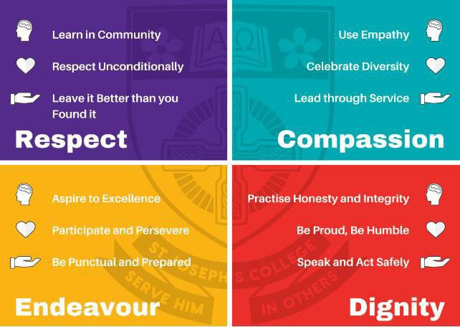

# Assessment Procedures

2024

**Contents**

[Assessment Procedures 1](https://twbcso-my.sharepoint.com/personal/kfellenberg_sjc_qld_edu_au/Documents/2019%20ASSESSMENT%20POLICY%20-%20SHARE/2019%20-%20Assessment%20Policy.docx#_Toc15380915)

Purpose 4

Principles 5

Scope 6

Formative Assessment Completion 6

Summative Assessment Completion 6

Short Course Completion 6

Promoting Academic Integrity 7

Location of Assessment Procedures 7

Expectations about engaging in learning and assessment 7

Due Dates 8

Assessment Calendars 8

Assessment Allocation Lessons 8

Extension Process 9

Non-Submission of a final response on due date 10

Submitting, Collecting and Storing 11

Submission 11

Collection 11

Storage 11

Exam Conditions and Equipment 12

Absent from Exams 13

Comparable Assessment 14

Ensuring Academic Integrity 15

Scaffolding 15

Checkpoints 16

Drafting 16

Feedback on Drafts 16

Spoken and Multimodal Assignments 17

In-class written tasks 17

Non-submission of Drafts 18

Non-submission of Final Assignment 18

Assessment Procedures for VET qualifications 19

Academic Support Notice 20

Academic Support Workflow 21

Assessment Submission Workflow 22

Managing Response Length 23

Strategies for Managing Response Length………………………………………………….23

Determining Length of a written response…………………………………………………...25

Determining Length of a non-written response……………………………………………...26

Managing Oral Assessment 27

Authenticating Student Responses 28

Inability to establish Authenticity 29

Access Arrangements and Reasonable Adjustments including illness and misadventure (AARA) 30

Internal Quality Assurance Processes 31

External Assessment Administration 32

Internal Moderation 33

Marking of Assessment and Recording of Student Achievement 33

Moderation of Assessment 33

Moderation comprises three (3) forms 33

Managing Academic Misconduct 34

Extenuating Circumstances 36

What are extenuating circumstances? 36

Key Personnel 37

# Purpose

St Joseph’s College is committed to an educational philosophy that encourages all students to achieve personal excellence by developing their talents and abilities.

This assessment procedure handbook incorporates the roles, responsibilities, processes and procedures used by St Joseph’s College to ensure academic integrity in relation to the submission of work, the development of assessment and the completion of all assessment items (including examinations).

Consequently it

* Provides information to students about expectations for assessment and their responsibilities
* Includes guidelines and information for all staff, including teachers, Curriculum Leaders and Administration about expectations and their roles and responsibilities

The Assessment Procedures is

* Communicated clearly to teachers, students and parents and carers
* Enacted consistently across all subjects within the College
* Based on information provided by the [QCE and QCIA policy and procedures handbook](https://www.qcaa.qld.edu.au/senior/certificates-and-qualifications/qce-qcia-handbook-2019), and QCAA syllabuses.

The roles and responsibilities outlined apply to all St Joseph’s College students, parents/carers and staff, and comply with the policies and procedures set down by the QCAA and the College.

It includes procedures and processes for:

* Promoting academic integrity
* Managing academic misconduct
* Applying for AARA (Access Arrangements and Reasonable Adjustments)
* Meeting deadlines for the submission of internal assessment instruments; and
* The administration of external assessment

# Principles

St Joseph’s College expectations are grounded in the principles of academic integrity and excellence. This includes assessment.

Assessment can include any examination, practical demonstration, performance or product that allows students to demonstrate the objectives as described by the syllabus.

Assessment should be:

* Aligned with curriculum and pedagogy
* Accessible and equitable for all students
* Evidence-based, using established standards and in the senior school instrument specific marking guides (ISMG) to make defensible and comparable judgements about student learning and achievement.
* Transparent, to enhance professional and public confidence in the processes used, the information obtained, and the decisions made; and
* Informative of where students are in their learning

Assessment Handbook: reviewed and updated January 2022

Page *| 5*

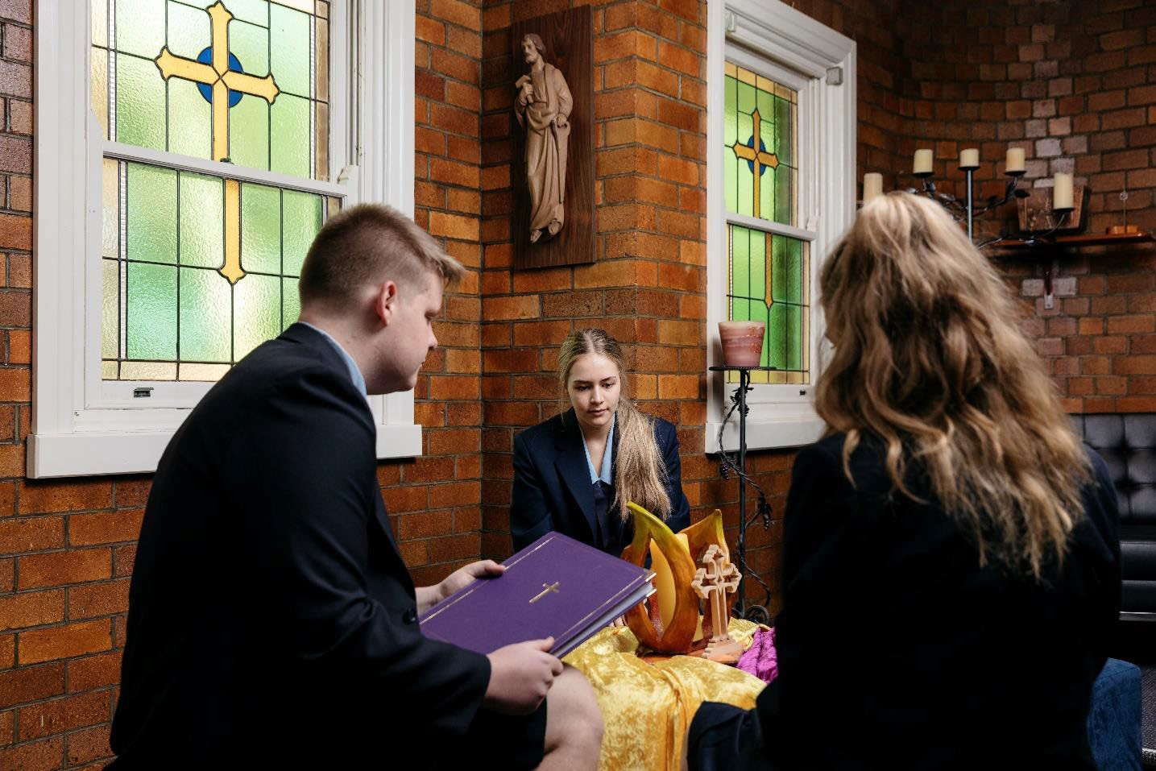

* Developed so that students are expected to demonstrate knowledge and skills, and enables authentication of their own individual student work.

# Scope

The scope of this Assessment Procedures Handbook includes Junior School subjects, Applied, Applied (Essential), General, General (Extension) subjects, Vocational Education Courses (VET) and Short Courses. The processes, procedures, roles, and responsibilities are designed to build capacity as students work towards summative assessment completion. The framework for the procedures is developed from the [QCE and QCIA policies and](https://www.qcaa.qld.edu.au/senior/certificates-and-qualifications/qce-qcia-handbook-2019) [procedures handbook](https://www.qcaa.qld.edu.au/senior/certificates-and-qualifications/qce-qcia-handbook-2019).

## Formative Assessment Completion

For all subjects, students are expected to engage in the learning in the subject or course of study including the course objectives. Students produce evidence of achievement in response to assessment planned for each subject in the junior school and each unit in the senior school.

St Joseph’s College gathers evidence of learning and matches this to relevant standards to make judgements.

## Summative Assessment Completion

#### General and Applied Subjects

To achieve an overall result, a student must complete Units 3 and 4, providing responses to each of the summative internal assessments and the external assessment for the subject.

A student cannot repeat one summative unit only (must study both Units 3 & 4 in Senior as a pair).

## Short Course Completion

There must be evidence of student responses to each summative internal assessment to achieve a course result.

# Promoting Academic Integrity

**Location of the Assessment Procedures Handbook**

In order that all stakeholders in our College Community are aware of the Assessment Procedures Handbook, it is centrally located on the St Joseph’s College Website. Updates about assessment calendars and Assessment due dates are on the College Intranet for students to access.

## Expectations about engaging in learning and assessment

St Joseph’s College has high expectations about academic integrity and students learning. Staff are supported to complete the academic integrity courses and the accreditation courses provided by the QCAA. St Joseph’s College encourages all teachers to review these courses annually and to apply for QCAA assessor roles.

Senior Students are required to complete the academic integrity courses provided by QCAA.

To ensure consistent application of the Assessment Procedures it may be revisited:

* at enrolment interviews
* at SET planning meetings
* during Joey’s Way lessons
* when Assessment Calendars are published
* when a task is handed to students
* in the newsletter and by email in response to phases of the Assessment Cycle.

St Joseph’s College emphasises the importance of sound academic practices and student responsibility. Our procedures are grounded in the principles that students can demonstrate what they know and can do by the due dates when they understand:

* **forward planning** (understanding the components of a task and how long each component might take to complete)
* **time management** (implementing a plan to achieve the assessment outcome, incorporating adjustments to this as needed. Allowing for unexpected events such as issues with technology or changes in personal circumstances)
* **note-taking and summarising** (independently synthesising research or gathering information into a new idea or summary)
* **referencing** (appropriately acknowledging the ideas, work or interpretation of others   
  including use of generative AI)
* **choosing appropriate examples** (selecting appropriate quotes or examples to support and argument)

###### argue or communicate meaning

* editing independently refining their own work and using feedback.

###### checking (self-assessing compliance with academic integrity guidelines before submitting responses)

The whole College Community: staff, students and parents/carers have roles and responsibilities in this context.

# Due Dates

St Joseph’s College is responsible for gathering evidence of student achievement **on or before the due date (in class time / 3pm in CANVAS)** for internal assessment instruments.

The final submission uploaded in Canvas (on or before the due date – in class time / 3pm ) is the task marked by teachers.

## Assessment Calendars

Assessment Schedules will

* Align with syllabus requirements
* Provide sufficient working time for students to complete the task
* Allow for internal quality assurance processes
* Enable timelines for QCAA quality assurance processes to be met
* Be clear to teachers, students, and parents/carers
* Be consistently applied
* Consider allocation of workload

All students will have electronic access to their assessment schedules, and it is their responsibility to adhere to these due dates.

Students are responsible for planning and managing their time to meet the due dates.

Students and parents can contact teachers and Curriculum Leaders via Phoning or emailing to help with communication.

Teachers are not able to grant extensions directly with students and parents/carers. Teachers, students, parents/carers must follow the St Joseph’s College Extension Process.

St Joseph’s College is required to adhere to QCAA policies about due dates accepting assignments only **on or before the due date (in class time / 3pm in CANVAS)** unless an extension has been approved by the College or through the QCAA AARA processes. For example, a student who is absent due to family holidays will not be granted an extension for an assignment as this doesn’t meet the AARA guidelines set by QCAA.

## Assessment Allocation Lessons

After an assessment piece has been disseminated, teachers need to ensure fairness in how many lessons are allocated to work on the piece consistently across classes.

Please note this will be **dependent on the subject area** and **decided across year leve**ls in consultations with the **teachers and Curriculum Leaders**.

# Extension Process

On occasions there may be extenuating circumstances beyond your control that prevent you from submitting an assessment item by the due date.

Circumstances which may warrant these are: prolonged illness prior to the due date (a medical certificate will be required) or compassionate grounds. St Joseph’s College follows the processes as outlined in the QCE and QCIA policies and procedures handbook for all students.

All AARA applications for summative assessments in Senior School - **Units 3 & 4** require QCAA approval and Principal approval.

If a student is eligible for **AARA and an extension** of time is granted, this becomes the **new due date** for this student.

* Student discusses with classroom teacher
* Teacher (if satisfied the student falls into the relevant AARA categories) advises the student to see the relevant Curriculum Leader and then the relevant Program Leader (Senior or Middle Years) or Assistant Principal Curriculum
* Student in Years 10-12 discusses with Assistant Principal Curriculum / Senior Learning Leader with relevant documented evidence (eg medical form)

Student in Years 7-9 discusses with Assistant Principal Curriculum / Middle School Learning Leader with relevant documented evidence (eg medical form)

* Assistant Principal / Senior Learning Leader or Middle School Learning Leader provides student with appropriate Extension Form (Junior or Senior) to be signed by Teacher, Curriculum Leader, Parent or Carer and is returned to the Senior or Middle School Learning Leader who will document.

Please note that the following documentation will also be required for students studying Units 3 and 4 in the Senior School.

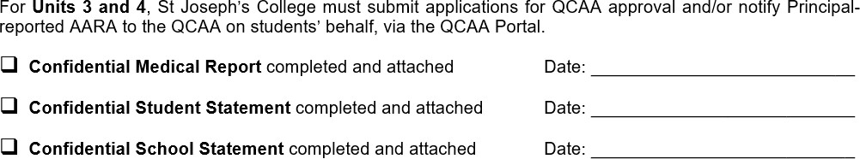

# Non-Submission of a final response on due date

In circumstances where students do not submit a final response to an assessment (other than unseen examinations) teachers make judgments **based on evidence** of student work collected for the purposes of **authentication**, during the assessment preparation period (**class work, a draft, rehearsal notes, photographs of student work, teacher observations**).

If a student is eligible for AARA and an extension of time is granted, this becomes the new due date for this student.

For students who are enrolled in a subject, but do not produce evidence **on or before the due date (in class time / 3pm in CANVAS)** as specified by the school and no other evidence is available, ***'Not-Rated'*** (NR) must be entered in the **Student Management System** for the Senior School students and this will also be used for **Internal Reporting Systems** used by St Joseph’s College for students from Years 7 to 12.

# Submitting, Collecting and Storing

## Submission

Where applicable assessment instruments (which may include checkpoints and drafts) will be submitted by the due date via **Turnitin** (St Joseph’s College Academic Integrity Software) using the Learning Management System LMS (**Canvas**).

Teachers and students will receive an automated receipt noting time and date of submission.

Copies of drafts/checkpoints are to be collected and may be stored in student folios at the time of the draft/checkpoint due date.

Teachers must inform students on what they need to produce in response to assessment such as:

* + conditions such as length and file type
  + how to submit responses to assessment (date, time, location, processes for submitting)

## Collection

Teachers in consultation with their Curriculum Leader will inform students of how assignments will be collected including uploading electronically where applicable via the LMS – Canvas.

If a student is absent from school without AARA, the assessment item must still be submitted on time and via **Turnitin** (if indicated on the assessment instrument) on the due date. Collection must be completed **on or before the due date (in class time / 3pm in CANVAS)**

## Storage

Storage of electronic assessment is through the St Joseph’s College Learning Management System (Canvas) through the Turnitin academic integrity Software.

In the Senior School – any hard copy assessment items (examinations) must be stored in clearly labelled student folios in filing cabinets as per instructions by Curriculum Leaders. Hard copies of exams or other assessment is scanned by the Curriculum Support Officer and saved electronically for confirmation uploads for QCAA.

All exams in the Junior School must be kept for a term after completion for parents’ request to view the assessment instrument.

All Assessment for **Units 1, 2, 3 & 4 for General and Applied subjects** in the Senior School must be kept **until the end of Semester One after the completion of Unit 4**. All **VET assessment** must be stored in keeping with the VET procedures.

# Exam Conditions and Equipment

* Students are not to bring a **mobile phone or a smart watch or fitness tracker** into the test room.
* Students may bring only **permitted equipment** (i.e. essential and optional) into the test room as outlined by their teacher or QCAA.
* Equipment may be inspected by a teacher at any time before, during and after a test session
* All equipment should be placed in a **clear plastic container**.
* Students are not to bring **food** into the test room (**unless approved under AARA**).
* Students are to **follow all directions** given by the teacher.
* Students enter the test room only when the teacher tells them to do so.
* Students will sit at the desk allocated by the teacher or identified by their place card.
* Students will **not talk or communicate** with other students after being admitted into a test room.

# Absent from Exams

Students who are unable to attend an examination owing to illness or other unavoidable circumstances, must have their parents or caregiver inform the College by phoning for the absence to be regarded as authorised.

Provided that acceptable evidence of such an absence (e.g. a medical certificate stating specifically the reason for absence) is presented for consideration by the Senior Years Learning Leader (Years 10-12) or the Middle Years Learning Leader (Years 7-9) or the Assistant Principal Curriculum in accordance with the [QCE and QCIA policies and procedures](https://www.qcaa.qld.edu.au/senior/certificates-and-qualifications/qce-qcia-handbook-2019) [handbook](https://www.qcaa.qld.edu.au/senior/certificates-and-qualifications/qce-qcia-handbook-2019) students may be granted permission to sit for the examination.

In the Junior School a student who is absent from an examination without the College knowing in advance of the examination, may not be granted the opportunity to complete an examination after the due date. Students who are unwell or other extenuating circumstances may be given the opportunity by their teacher to complete assessment.

In the Senior School **only students with AARA** or for **extenuating** circumstances will a student who is absent from an examination without the College knowing in advance of the examination, be granted the opportunity to complete an examination after the due date. **This will be decided in consultation with Queensland Curriculum Assessment Authority (QCAA) and the College Principal.**

**Students who attend TAFE, School Based Apprenticeships (SBA), Traineeships (SBT) or other learning environments outside of the College must attend school when assessment is scheduled. This includes exams, spoken tasks or practical assessment.**

Students with known absences **(sporting commitments)** will need to meet with the Senior or Middle Years Learning Leader or Assistant Principal in advance as changes of examination dates may not be approved and in particular Senior students may be given a **Not-Rated (NR)** which will affect their QCE points and ATAR calculations.

Examination and Assessment dates will not be changed for students going on family holidays and these students will receive Not-Rated for examinations. Assignments would need to be completed and submitted on or before the due date **(in class time / 3pm in CANVAS)**.

###### Under no circumstances will examination dates be brought forward for a student to complete before the due date.

# Comparable Assessment

A comparable assessment instrument **is an alternative assessment instrument that is used when an endorsed assessment instrument cannot be used for an individual student or small groups of students within the cohort**. Situations or scenarios occasioning use of a comparable assessment instrument could include:

##### illness preventing a student from attending an examination.

##### A comparable assessment instrument allows students to use knowledge and skills required for the endorsed assessment instrument and is designed to gather the evidence of student learning using the assessment objectives, ISMG or ISSM and topics of the syllabus.

In the case that a school has determined a comparable assessment instrument needs to be developed, **the Assistant Principal, Senior Years Learning Leader and/or Curriculum Leader** will contact the **QCAA for support and advice**.

##### The following adjustments are accepted for comparable assessment in both the Junior and Senior School as schools are best placed to make decisions about the amount of adjustment made to an endorsed assessment instrument, which may include replacement of items or variation to:

##### the stimulus material

##### text within items

##### numerical values within items

##### parameters within short response items.

# Ensuring Academic Integrity

## Scaffolding

###### Scaffolding for assessment is limited to:

* Checkpoints that students can use to manage completion of components of the assessment instrument
* Guiding students to make predictions and/or reflect on their learning to complete the requirements of the assessment instrument;
* Providing prompts and cues for students about the requirements for their responses.

When scaffolding, it is important that the **integrity** of the requirements of the task or assessment instrument are maintained so a **student response is their own**.

St Joseph’s College has internal quality assurance processes for each assessment instrument. This process will check to ensure that scaffolding does not lead to a predetermined response and allows students to independently demonstrate the objectives being assessed. **These quality assurance processes are coordinated by the Curriculum Leader.**

Across the phases of learning there will be a **gradual release of responsibility to students.**

## Checkpoints

The monitoring of student progress is detailed by **checkpoints on task sheets**.

Teachers will use these checkpoints to identify and support students to complete their assessment. Teachers may use defined checkpoints to:

* clarify assessment expectations for students (e.g. task requirements, how judgments are made)
* discuss progress towards the task completion
* help students develop strategies to submit assessment by the due date

###### gather evidence on or before the due date (in class time / 3pm in CANVAS)

* provide points of intervention, if needed

###### embed authentication strategies

Prompt communication with the Curriculum Leaders and parents or carers, about potential issues will help resolve any potential assessment completion issues.

## Drafting

Drafting is an important part of teaching and learning.

Types of drafts differ depending on subject, for example: written draft; rehearsal of performance pieces; or a product in development. **Drafts are used as evidence of student achievement** in the case of illness or misadventure, or non-submission for other reasons.

### Feedback on Drafts

* Must not compromise authenticity of student response by adding ideas
* In the Senior School, may indicate key errors in spelling, grammar, punctuation and calculations, and remind the student that the draft requires more editing, but should not edit or correct all errors in the draft.
* Is provided on a maximum of **one draft** of each student’s response.
* draft feedback may be provided on a complete draft, or sections of a draft as indicated on the

Task Sheet.

* Is a consultative process, **not a marking process**
* Will be provided within two **weeks** of submission of draft
* Students who submit their drafts after the due date/time **may not** be eligible for feedback
* A copy of the feedback and draft is stored in the student’s folio (in the Senior School). This may be electronic. (removed)
* Feedback on the draft will be saved in Canvas for students to refer to.
* **If a draft was an expectation from the teacher**, parents and caregivers are notified by email or phone call about non-submission and **Academic Support Processes** may be followed.
* Copies of drafted pieces of work must be retained and submitted with the final piece of work.(remove)

###### Drafts can be completed as per the teacher’s preference and could include:

* + Handwritten notes on a printed draft.
  + Typed notes using the Draw or Review Tool on a digital document (e.g. MS Word or OneNote).
  + Recorded audio/visual comments on a digital document.
  + Speed Grader function of Canvas.
  + Face-to-face conference
  + Whole Class feedback either face-to-face or via Canvas

### Spoken and Multimodal Assignments

* The same drafting requirements for the script as for written assignments
* Teachers may watch a section of the performance rehearsal and give verbal feedback and may be done outside of class time.
* Teachers may use a video uploading program (such as FlipGrid) to give minimal written feedback on recorded drafts.
* Presentation slides can and should be submitted with the paper script for draft feedback.
* A recorded spoken draft is required as per the Task Sheet

**In-class written tasks and exams**

Tasks in Years 7-10 that are completed in class over a series of lessons could be given class feedback only. This feedback could be given in the subsequent lesson allocations. Feedback will be written on exam papers for students and parents to view. Exams **cannot** be photocopied and sent home to parents. If a parent requests to view feedback this can be arranged via a face-to-face interview with the classroom teacher and / or Curriculum leader.

**Non-submission of Drafts & Checkpoints**

If a teacher has requested a draft for a student and the student does not produce a draft parents/carers are notified about non-submission of checkpoints or drafts

1. Teacher and Curriculum Leader completes Academic Support Notice
2. Teacher may contact parent or carer
3. Academic Support Notice sent to Curriculum Support Officer
4. Letter sent to parents/cares via Sentral about Academic Support
5. Student attends Academic Support to complete the draft/checkpoint for teacher
6. Academic Support can either be held by
   1. Teacher arranged with parent and student (as outlined in the Academic support letter)
   2. Curriculum Leader (as arranged with their staff)
   3. Assistant Principal Curriculum & Curriculum Leaders – Thursday 3.15 – 4.15pm (library Seminar room). Teachers who have students on academic support are requested to attend at the start of the session to assist students.

## Non-submission of Final Assignment

If a student fails to submit an assignment on the due date, **teachers will mark the draft** or checkpoint.

If no draft was submitted, students will be asked to write what they can and know during the lesson or in break time the **same day** and this will be marked by the teacher.

Parents or carers are notified about **non-submission of assignment** by the classroom teacher and the result will be based on the draft or work submitted in that lesson.

1. **Teacher records in Sentral** – Behaviour Notes and notifies Curriculum leader and relevant Program Leader (Senior or Middle School Learning Leader)
2. **Teacher contacts parent or carer** and marks the evidence provided.

**Assessment Procedures for VET qualifications taught at St Joseph’s College Toowoomba**

##### Students will complete the modules of competency and required assessment tasks that clearly outlines the requirements and expectations for the task via the VET portal.

##### Students will be informed by the teacher the due date for submission of individual class tasks. Final submission of modules is Week 9 each term as per the assessment calendar.

##### Students will have two opportunities to submit a response for assessment. The first submission will be considered and will be marked and returned with feedback to guide the student in improving their response if required.

##### The student can then make any necessary adjustments to their response and submit their second and final response for assessment.

##### If the final response is not deemed competent, the student will be required to attend academic support after school to finalise their response.

##### If this submission is still not deemed competent, the student will be deemed Not Yet Competent for that assessment task and at risk of not completing the certificate.

##### If the student is deemed Not Yet Competent for an assessment task, parents will be notified via an “**at risk letter**” and a meeting will be requested for the parent and student to attend with the classroom teacher, Curriculum leader, Senior Years Learning leader or Assistant Principal depending on the individual situation and severity.

##### All assessments will be marked against the relevant unit of competency and will be conducted in accordance with the relevant training package requirements and assessment guidelines.

##### The assessment process will be fair, valid, reliable, flexible and transparent, ensuring that all students have an equal opportunity to demonstrate their knowledge and skills.

##### The assessment results will be recorded accurately and securely and will be used to inform the student's progress and provide feedback on areas for improvement.

##### Any issues or concerns with the assessment process or results can be raised through the appropriate channels, firstly with the classroom teacher, then Curriculum leader, Senior Years Learning leader and finally the Assistant Principal Curriculum for review and resolution.

# Academic Support Notice

For a letter to be generated in Sentral to notify parents/carers of Academic Support please follow the following process

✓ Teacher notifies student and Curriculum Leader

✓ Teacher emails Curriculum Support officer by Tuesday 3pm with details for the referral to academic support.

✓ Curriculum Support Officer enters relevant details into Sentral and generates email to parents.

✓ Parents click onto a link in the letter to notify the Curriculum Support officer that the parent has approved the after school Academic Support sessions.

✓ Rolls are marked in Teams to indicate a student has attended an afterschool Academic Support sessions. Sessions held at lunchtime are the responsibility of the teacher to supervise and keep records of attendance.

# Academic Support Workflow

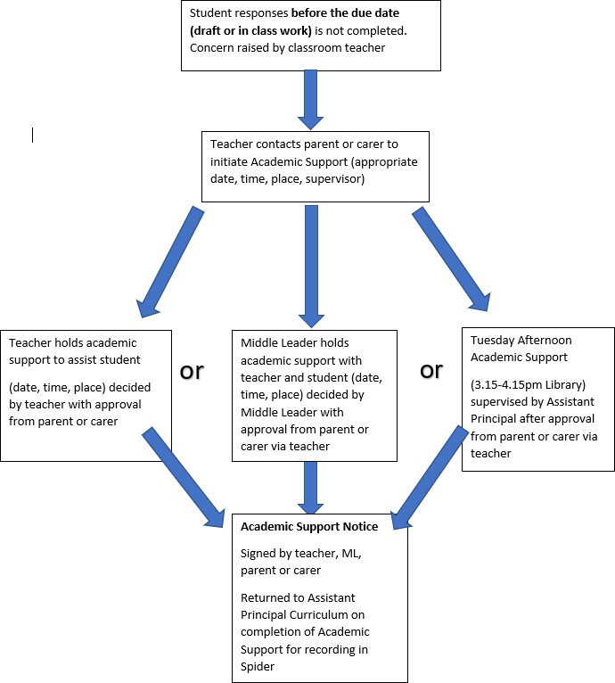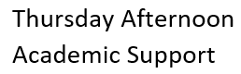

Parents are notified via Sentral. Parents are able to respond to the letter by clicking on a link to provide permission for after school sessions.

Parents are encouraged to contact the teacher if they have any questions.

Resources

* QCE and QCIA policy and procedures handbook
* Internal quality assurance workflow
* Strategies for quality assuring judgments: Information to teachers

* The due date encompasses extensions for access arrangements and reasonable adjustments (AARA) and principal-approved extensions.

Apply quality assurance (QA) processes to judgments, using the agreed strategies.

The assessment must be marked as Not Rated (NR).

Make judgments about student achievement based on the available evidence.

Is any evidence available from the preparation of the response?

# Assessment Submission Workflow



## Managing Response Length

Response lengths as specified by syllabus documents and guidelines must be followed. The procedures below support students in managing their response lengths:

* Internal quality assurance processes to ensure valid assessment instruments of appropriate scope and scale
* Subject specific strategies about responding purposefully within the prescribed conditions of the task are embedded in teaching and learning programs

**Response length information is provided to**:

* ensure equity of conditions for all students
* indicate the scope and scale of the response required
* support students to develop skills in managing the length, scope and scale of their responses appropriately
* ensure that internal assessments developed for General, General (Extension) and Applied (Essential) subjects meet the requirements for endorsement
* ensure that internal assessments developed for Applied subjects allow students to demonstrate the syllabus objectives across the range of standards and match the conditions described in the syllabus.

**Teachers will mark only the work that meets the required length,** as per the syllabus, excluding evidence outside the required written or spoken length.

**For Confirmation in the Senior School,** St Joseph’s College will only submit the student work used to determine a mark or annotate the student work to indicate the evidence used to determine a mark, where the response has exceeded the word length, duration of time, or page count, as required by the syllabus.

**Strategies for Managing Response Length**

* develop valid assessment instruments of suitable scope and scale
* emphasise the response length mandated by the syllabus
* implement teaching and learning strategies so students can learn effective skills to use when responding to assessment instruments, for example,
  + provide examples of assessment responses within the required response length,

i.e. word length, duration of time or page count

* + explicitly model how to create a draft and edit a response to an assessment in the required mode, i.e. written, spoken, multimodal, performance
  + provide students with feedback at checkpoints and on the draft in the required mode if the response does not match the required length
  + give advice to students about how to develop ideas and synthesise information relevant to the task and objectives being assessed to meet the assessment conditions
* provide opportunities for students to practise responding within the required word length in examinations
* ensure a process is enacted for compiling and editing supporting evidence in performance assessments (e.g. in Physical Education) so that it meets the syllabus condition for length
* in performances with more than one student (e.g. in Drama), monitor students’ text selections to ensure they meet the syllabus performance time requirements for active engagement for each student.

#### After assessment is submitted

For written responses with a word or page limit, or responses with a duration (e.g. presentations or recordings),

strategies include:

* + - * **marking only the evidence in the student response that meets the assessment conditions** for response length, that is, marking from the beginning of the response up to the point where the response meets the required length, and excluding evidence after that point.
      * **allowing a student to redact a response** to meet the required length before a judgment is made on the evidence in the student response. **Teachers are not to redact a student response**. It is also not appropriate for a student to redact a response that is
        + produced under exam conditions
        + in an assessment that requires a continuous response, such as a presentation or recording.

**Note, however, that when marking student responses, schools cannot:**

* change the tool (e.g. ISMG, instrument-specific standards, or reporting standards) being used for making a judgment
* penalise students for submitting an over-length response by arbitrarily reducing their result, e.g. introducing a 2-mark penalty for an over-length response
* increase the upper limit of a length described as a range in the syllabus, e.g. allowing a tolerance of +10%
* increase working time, e.g. allowing students to take an over-length assignment home to redact.

In any case where the complete student response is not used to determine the result, teachers annotate the student response, ISMG or instrument-specific standards to indicate which evidence was used to make a judgment.

### Determining length of a response

Response length requirements are expressed in syllabuses as a word length, time duration or page count, and vary according to the technique and response type, such as written, spoken/signed and multimodal or performance responses.

Elements to be included in or excluded from the word length or page count of a written response are provided in the following table.

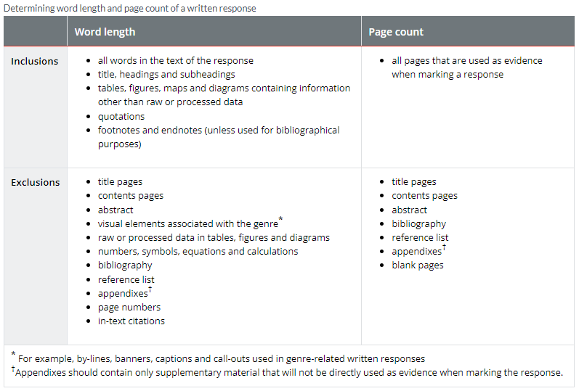

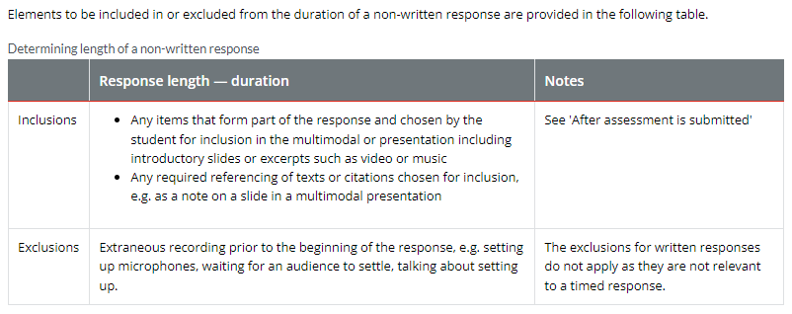

## Managing Oral Assessment

At St Joseph’s College many subjects require oral assessment instruments. Often a spoken task carries the same weight as any written task in forming part of a folio of work. Therefore, it is **not an optional task**.

When completing an oral assessment instrument, you may be required to **submit a script**.

* As part of the Syllabus and / or the Oral Assessment Instrument students may be required to pre-record oral presentations. If a student selects this option in consultation with their teacher, the taping is to be done in the students’ own time using their own equipment.
* All pre-recorded orals must be then played to the class (**with the student present to view**). On the due date (or first day of oral presentations) all students must submit a **complete transcript**

(as well as copies of any visual materials to accompany the speech).

This ensures a level of equity given that students may present over several days.

All students must arrive on the due date prepared to present. If the oral assessment involves pre- recording, these must be submitted **on or before the due date (in class time / 3pm in CANVAS)**

A pre-recording not submitted **on or before the due date (in class time / 3pm in CANVAS)** will be considered a **non-submission.**

The classroom teacher will decide whether they will ask for volunteers to present first or undertake a random draw.

###### All students are to present in front of the audience of their peers in their class.

As with any assignment, students may request AARA **(Access Arrangements and Reasonable Adjustments)** with the presentation of a medical certificate or after discussions with Program Leader of Student Services and Curriculum Leader or for Senior School students the Senior Program Leader or Assistant Principal Curriculum.

## Authenticating Student Responses

Accurate judgements of student achievement can only be made on student assessment responses that are authenticated as the student’s own work.

St Joseph’s College uses strategies across all subjects and phases of learning.

These include, but are not limited to:

* Assessment tasks changing from year to year;
* Assessment tasks that expects each student to independently develop a unique response
* Monitor, collect, observe progressive samples of each student’s work at various stages. This process could be documented using an authentication record, checklist or photographs
* Interview or consult with a student at check points during the development of the response to ensure that it is based on the student’s own work
* For text, analyse final student responses using plagiarism-detection software (Turnitin)   
  or other software, if available and appropriate.
* Internal quality assurance processes comparing responses of students who work in groups and cross-marking in subjects with multiple cohorts
* Assessment schedule that ensures sufficient time for completion of tasks and monitoring of development of responses.
* Interview a student if their authorship of text, visual, audiovisual, performance or spoken/signed responses may have been compromised by, for example by use of generative AI, to determine their understanding and familiarity with their responses.

Students should:

* complete responses during the designated class time to ensure teachers can observe the development of work and authenticate student responses
* participate in authentication processes as required by schools, such as to
  + sign a declaration of authenticity
  + submit a draft
  + submit the final response using plagiarism-detection software, where required
  + participate in interviews during and after the development of the final response.

Parents/carers can:

* support the efforts of teachers and students to authenticate student responses by ensuring that their child understands their responsibilities to maintain academic integrity and that they are aware of and follow the guidelines for drafting and providing feedback on a draft student response.

### Inability to establish Authenticity

Responses that are not the student’s own cannot be used to make a judgment. When authorship of student work cannot be established, or a response is not entirely a student’s own work, St Joseph’s College will:

* provide an opportunity for the student to demonstrate that the submitted response is their own work
* make a judgment about the student’s knowledge and skills using the parts of the response that can be identified as the student’s own work.

In these instances, judgments about student achievement are made using the available student work and relevant ISMG, instrument-specific standards or syllabus standards.

# Access Arrangements and Reasonable Adjustments including illness and misadventure (AARA)

St Joseph’s College is committed to reducing barriers to success for all students. Access arrangements are actions taken by the school to minimise, as much as possible, barriers for a student whose disability, impairment, medical condition or the circumstances may affect their ability to read, respond to or participate in assessment.

St Joseph’s College follows the processes as outlined in the [QCE and QCIA policies and procedures](https://www.qcaa.qld.edu.au/senior/certificates-and-qualifications/qce-qcia-handbook-2019) [handbook](https://www.qcaa.qld.edu.au/senior/certificates-and-qualifications/qce-qcia-handbook-2019) for all students.

All evidence that decisions are based on will be recorded in the student’s file.

All AARA applications for summative assessments in **Units 3 & 4** require QCAA approval.

If a student is eligible for **AARA and an extension** of time is granted, this becomes the **new due date** for this student.

It is not appropriate to award a lower result, mark or standard as a penalty for late or non-submission, as evidence is to be matched to the relevant syllabus marking guides or standards.

Students are **not eligible for AARA** on the following grounds:

* unfamiliarity with the English language
* teacher absence or other teacher-related difficulties
* matters that the student could have avoided (e.g. misreading an examination timetable, misreading instructions in examinations)
* matters of the student’s or parent’s/carer’s own choosing (**e.g. family holidays**)
* matters that the school could have avoided.

For any of the above grounds, when a student does not submit a response to an assessment instrument **on or before the due** date **(in class time / 3pm in CANVAS)** set by the College, a result is awarded using an evidence from the preparation of the response that is available **on or before the due date (in class time / 3pm in CANVAS)**.

# Internal Quality Assurance Processes

St Joseph’s College’s quality management system includes two points of quality assurance in the Assessment workflow. The timing of these processes is negotiated within academic departments and overseen by the Curriculum Leader.

* Quality Assurance of all assessment instruments before they are administered to students and in the case of internal assessment instruments for Units 3 & 4 in the Senior School prior to submission to the QCAA. Curriculum Leaders and teachers will use the Quality Assurance tools provided by QCAA in the [QCAA Portal.](https://www.qcaa.qld.edu.au/portal/home/landing/%23/home)
* Quality Assurance of judgments about student achievement contributing to results and reporting prior to results being provided. Curriculum Leaders and their departments are free to choose the type of quality assurance processes as this will depend on the size of the cohort, number of classes and the year level.

Internal processes that may occur before students’ results are provided are clearly communicated when assessment tasks are handed out.

Students are also made aware of the external processes that may occur before their results are provided, for example: all marks for summative internal assessment for General and General (Extension) subjects are **provisional** until they are confirmed through the **confirmation process.**

Results for Applied and Applied (Essential) subjects and Short Courses may be subject to advice from QCAA.

# External Assessment Administration

External assessment is developed by the QCAA for all General and General (Extension) subjects. St Joseph’s College will follow the [QCE and QCIA policies and procedures handbook](https://www.qcaa.qld.edu.au/senior/certificates-and-qualifications/qce-qcia-handbook-2019).

External assessment is:

* + identified in syllabuses provided by QCAA
  + common to all schools
  + administered by schools under the **same conditions** at the **same time** and **on the same day**
  + developed and marked by the QCAA according to a commonly applied marking scheme.

# Internal Moderation

## Marking of Assessment and Recording of Student Achievement

From the date of submission of an assessment task, teachers must ensure the following tasks are completed in a timely manner (**2 weeks)**

* Mark the assessment item and include quality feedback to students on their achievement and recommendations for future improvements
* Discuss results and provide feedback to students
* Record results on individual student profiles and on the department’s electronic markbook in a timely manner (for junior students – at the end of each term, for senior students – at the end of each assessment piece)

Teachers of competency-based subjects must ensure they update the appropriate competency completion to reflect student achievement towards the qualification as students complete modules.

## Moderation of Assessment

St Joseph’s College has a strong focus on quality assurance and ensuring students are accurately awarded results for completed assessment.

Moderation is the process of ensuring that assessment is valid, reliable and fair, and refers to the processes of moderating grades and moderating individual assessment items.

### Moderation comprises three (3) forms

* **Moderation of individual assessment** marks: **samples** of marked assessments at each grade will be moderated by academic peers internally to establish reliability of marking.
* **Moderation of unit marks (final grades):** this is conducted by the subject teachers under the guidance of the Curriculum Leader.
* **External Moderation** of units and marks through **Endorsement and Moderation** (QCAA Procedures)

# Managing Academic Misconduct

St Joseph’s College is committed to supporting students to complete assessment and to submit work that is their own, and minimising opportunities for academic misconduct. There may be a situation when a student inappropriately and falsely demonstrates their learning. The following are some examples of academic misconduct **but is not limited to**:

|  |  |  |  |
| --- | --- | --- | --- |
| **Type of misconduct** | | **Examples** | |
| **Cheating while under supervised conditions** | | A student:   * begins to write during perusal time or continues to write after the instruction to stop writing is given * brings unauthorised equipment or materials (eg **smartphone or smart watch, fitness tracker)** * has any notation written on the body, clothing or any object brought into an assessment room * communicates with any person **or tool** other than a supervisor during an examination, e.g. through speaking, signing, electronic device or other means such as passing notes, making gestures or sharing equipment with another student. | |
| **Collusion** | | When:   * more than one student works to produce a response and that response is submitted as individual work by one or multiple students * a student assists another student to commit an act of academic misconduct * a student gives or receives a response to an assessment. | |
| **Contract cheating** | | A student:   * pays for a person or a service to complete a response to an assessment * sells or trades a response to an assessment. | |
| **Copying work** | | A student:   * deliberately or knowingly makes it possible for another student to copy responses * looks at another student’s work during an exam * copies another student’s work during an exam. | |
| **Disclosing or receiving information about an assessment** | | A student:   * gives or accesses unauthorised information that compromises the integrity of the assessment, such as stimulus or suggested answers/responses, prior to completing a response to an assessment * makes any attempt to give or receive access to secure assessment materials. | |

|  |  |
| --- | --- |
| **Fabricating** | A student:   * invents or exaggerates data * lists incorrect or fictitious references. This includes incorporation of false or misleading information from the use of generative AI and provide information and/or references that are not factual**.** |
| **Impersonation** | A student   * arranges for another person to complete a response to an assessment in their place, e.g. impersonating the student in a performance or supervised assessment. * completes a response to an assessment in place of another student.This includes use of generative AI to alter images or recordings to adapt unreferenced material or adopt identities of other presenters or performers for audio, visual and audiovisual assessment responses. |
| **Misconduct during an examination** | A student distracts and/or disrupts others in an assessment room. |
| **Plagiarism or lack of referencing** | A student completely or partially copies or alters another person’s work or creates work using generative AI tools without attribution (another person’s work or AI this may include text, audio or audiovisual material, figures, tables, design, images, information or ideas).  The use of Artificial Intelligence (AI) without appropriate referencing and acknowledgement is strictly prohibited. |
| **Self-plagiarism** | A student duplicates work, or part of work already submitted as a response to an assessment instrument in the same or any other subject. |
| **Significant contribution of**  **help** | A student arranges for, or allows, a tutor, parent/carer or any person in a supporting role to complete or contribute significantly to the  response |

##### When authorship of student work cannot be established or a response is not entirely a student’s own work, the College will provide an opportunity for the student to demonstrate that the submitted response is their own work in consultation with the Curriculum Leader.

Results will be awarded using any evidence from the preparation of the response that is available that is verifiably the student’s own work and that was gathered in the conditions specified by the syllabus, **on or before the due date (in class time / 3pm in CANVAS).**

#### In the case of exams, students will be awarded Not-Rated (NR).

# Extenuating Circumstances

## What are extenuating circumstances?

These are circumstances beyond a student’s control which have affected their performance in assessments (whether an examination, essay, practical or other form of assessment).

They may include:

* Bereavement – death of a close relative
* Serious short-term illness or accident (of a nature which, would have led to an absence)
* Evidence of a long-term health condition worsening or of a change in a fluctuating condition
* Significant adverse personal/family circumstances
* Other significant exceptional factors for which there is evidence that performance has been impaired.

The following **may not be regarded as extenuating circumstances**:

* Alleged statement of a medical condition without reasonable evidence (medical or otherwise) to support it
* Alleged medical circumstances outside the relevant assessment period or learning period for which appropriate adjustments for extenuating circumstances have already been made.
* Alleged medical condition supported by “**retrospective” medical evidence** – that is, evidence that is not in existence at the same time as the illness, e.g. a doctor’s note which states that the student was seen (after the illness occurred) and declared they had been ill previously, except where there is evidence that the student had unknown or undisclosed mental health difficulties.
* Long term health condition for which the student is already receiving reasonable or appropriate adjustments.
* Retrospective disclosure of circumstances or withholding of details on grounds of sensitive personal, family or cultural reasons.
* Minor illness or ailment which is unlikely to have had a significant impact on the student’s performance.
* Failure to attend an examination due to misreading the examination timetable.
* Inadequate planning and time management.
* Having more than one examination on the same or consecutive days.
* Any event that could have been reasonably expected or anticipated, such as sporting events or pressures from paid employment, or other study commitments.
* Events such as holidays and weddings.
* Failure to follow good practice regarding use of IT (e.g. failure to back-up documents or protect against computer viruses)

## 2024 Key Personnel

**Kerrie-Anne Fellenberg** Assistant Principal – Curriculum Email: [kfellenberg@sjc.qld.edu.au](mailto:kfellenberg@sjc.qld.edu.au)

**Kellie-Marie Ford**

Assistant Principal Religious Education Email: [kford@sjc.qld.edu.au](mailto:kford@sjc.qld.edu.au)

**Karen Tobin**

Senior Learning Leader Email: [ktobin@sjc.qld.edu.au](mailto:ktobin@sjc.qld.edu.au)

**Kirstie Andrews**

Middle School Learning Leader Email: [kandrews@sjc.qld.edu.au](mailto:kandrews@sjc.qld.edu.au)

**Emma Chalmers**

Curriculum Leader – English & Languages Email: [echalmers@sjc.qld.edu.au](mailto:echalmers@sjc.qld.edu.au)

**Peter Keightley**

Curriculum Leader – Mathematics Email: [pkeightley@sjc.qld.edu.au](mailto:pkeightley@sjc.qld.edu.au)

**Cameron Love**

Curriculum Leader – Science Email: [clove@sjc.qld.edu.au](mailto:clove@sjc.qld.edu.au)

**Andrew Fellenberg**

Curriculum Leader – Humanities & Commerce Email: [afellenberg@sjc.qld.edu.au](mailto:afellenberg@sjc.qld.edu.au)

**Mitchell Kilgour**

Curriculum Leader – HPE Email: [mkilgour@sjc.qld.edu.au](mailto:mkilgour@sjc.qld.edu.au)

**Brian Cantwell**

Curriculum Leader – Technology Email: [bcantwell@sjc.qld.edu.au](mailto:bcantwell@sjc.qld.edu.au)

**Chrissy Dwyer**

Curriculum Leader – The Arts Email: [cdwy](mailto:cdwyer@sjc.qld.edu.au)[er@sjc.qld.edu.au](mailto:er@sjc.qld.edu.au)

**Darcy Goodall**

Program Leader – Student Services Email: [dgoodall@sjc.qld.edu.au](mailto:dgoodall@sjc.qld.edu.au)

**Maree Harman**

Careers Practitioner

Email: [mharman@sjc.qld.edu.au](mailto:mharman@sjc.qld.edu.au)